**August Recess Toolkit 2013**

TABLE OF CONTENTS

Goals, Timeline and CALLS! 1

Political Process 2

Scheduling Your Lobby Visits 3

Town Hall Preparation Tips 4

Working the Media 5

Sample Announcements to your Chapter 6

Call for Case Examples Flyers 7

Sample Email to Coalition Partners 8

**Goals**

AILA, along with many national and local partner organizations, will be working to reach three main goals this August recess:

1. Influence moderate Representatives to support bipartisan, common sense immigration reform with a road to legalization and eventual citizenship.
2. Encourage House leadership to move forward with a vote on immigration reform when Congress comes back from recess.
3. Create a positive media narrative on immigration reform heading into September.

**Timeline**

AUGUST RECESS

August 5th through September 8th: members of Congress head back to their districts for a five week in-district work period. During this time many of these Members will be hosting public events, such as town halls, forums, fundraisers and other constituent events.

September 9th through 20th: Congress is in session

September 23 – 27th: Congressional Recess

**CALLS! CALLS! CALLS!**

**Call your Representative in the House once a day** (and spread the word to your family, clients and friends to do the same) making the case for immigration reform and why we need a vote.

**SCRIPT**: “My name is [XXX] from [CITY] and I am calling in support of bipartisan immigration reform with a road to legalization and citizenship. The time is now to pass real solutions to fix our broken immigration system.”

**Political Process**

THE SENATE ([www.aila.org/senatebill](http://www.aila.org/senatebill))

On June 27, 2013 the Senate voted 68-32 to pass [Senate Bill 744](http://www.aila.org/senatebill) (read the [AILA/AIC section-by-section summary](http://www.aila.org/content/default.aspx?bc=6755|37861|25667|44901) of the bill as passed out of the Senate.) The most significant amendment to the bill, the "[border surge package](http://www.aila.org/content/default.aspx?bc=37844|11536|44879)" offered by Senators Corker (R-TN) and Hoeven (R-ND), came during the end of the [three week debate on the Senate floor](http://www.aila.org/content/default.aspx?bc=44069|44808) and prompted many Republicans (14 in total) to vote yes on the final bill. Although AILA remains gravely concerned that the 'border surge' component added will bring real harm to border communities, this bill represents the best shot at real immigration reform, and for that reason AILA supports it.

THE HOUSE ([www.aila.org/house](http://www.aila.org/house))

Now that the Senate has passed a bill all eyes turn towards the House of Representatives, led by House Speaker John Boehner (R-OH), has a number of options moving forward on immigration reform:

* **Consider piecemeal legislation** that could be sent to a conference committee* with the Senate

The *House Judiciary Committee*, chaired by Rep. Bob Goodlatte (R-VA), has passed:

* + [H.R. 1773](http://www.aila.org/content/default.aspx?bc=11536|44245), the Agricultural Guestworker Act
  + [H.R. 2278](http://www.aila.org/content/default.aspx?bc=11536|44723), the Strengthen and Fortify Enforcement (SAFE) Act
  + [H.R. 1772](http://www.aila.org/content/default.aspx?docid=45034), the Legal Workforce Act (mandatory E-Verify)
  + [H.R. 2131](http://www.aila.org/content/default.aspx?bc=11536|45030), Supplying Knowledge Based Immigrants and Lifting Levels of STEM Visas (SKILLS) Act.

The *House Homeland Security Committee*, chaired by Rep. Kevin McCaul (R-TX), has passed:

* + [H.R. 1417](http://www.aila.org/content/default.aspx?bc=11536|44716), the Border Security Results Act of 2013.
* **Move their own comprehensive bill** that could then be sent to a conference committee with the Senate's bill. Although the bipartisan group in the House (the *Gang of Seven*) has said they are continuing to work on a comprehensive bill to be introduced in the House soon, hopes are dimming that the Speaker will allow that comprehensive bill, if even introduced, to ever have a vote.
* **Consider the Senate bill**, S.744, directly; however, Speaker Boehner (R-OH) has stated [on numerous occasions](http://www.speaker.gov/press-release/joint-statement-house-gop-leaders-immigration-reform) that the Senate bill is dead on arrival in the House.
* **Do nothing** and let immigration reform die until the next session of Congress begins in January 2015 (after the elections in November 2014).

OTHER POLITICAL CONSIDERATIONS

* Some of the Republicans most opposed to immigration reform (ex. Steve King (R-IA)) have said they will **vote against any bill** pertaining to immigration reform brought to the House floor (even the terrible [SAFE Act](http://www.aila.org/content/default.aspx?bc=11536|44723), which he supports) because they do not want a conference-able bill to pass the House and then be used to negotiate with the Senate bill.
* **Minority Leader Nancy Pelosi** (D-CA) sent a letter to the Speaker indicating that Democrats would not vote for any package that doesn’t include legalization, although they would be willing to vote for piecemeal bills.
* **The *Hastert Rule***, an informal principle used by House Republican Speakers on a voluntary basis in which they pledge not allow a vote on a bill unless a majority of the majority party supports the bill—in today’s House that means at least 117 Republicans must be in support of a bill before it gets a vote on the floor of the House. Speaker Boehner has said in remarks that he will follow the *Hastert Rule* in regards to immigration reform, so a coalition of Republican and Democratic votes to reach the 218 threshold (simple majority) to pass comprehensive immigration reform may not be enough.

**\*Conference committee**: A committee that operates after the House and the Senate have passed different versions of a bill. Conference committees exist to draft a compromise bill that both houses of Congress can accept. Both the Senate and the House must eventually pass identical legislation for a bill to become law.

**Scheduling Your Lobby Visits**

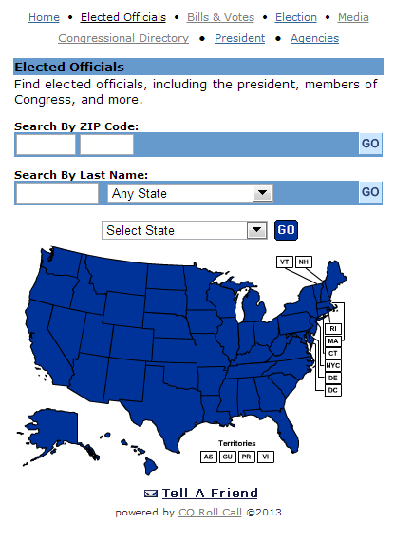Requesting a Meeting

Call the Congressional member’s office and ask to speak to the staffer responsible for scheduling meetings with the member of Congress and the person who handles immigration for the office. Find out their preferred method for appointment requests (fax, email, or over the phone). Let the scheduler know that you’re calling to schedule a meeting to discuss immigration reform efforts in the House, and make sure to mention that you are a constituent!

You can find telephone numbers for the D.C. and district offices on [AILA’s Contact Congress website](http://capwiz.com/aila2/dbq/officials/) or be connected directly by calling the Congressional Switchboard: **202.224.3121**.

**REMEMBER**: You may have to follow up multiple times to get an appointment scheduled, but be persistent. As a constituent you have the right to meet with your elected officials or their staff.

AILA’s [**Elected Official Directory**](http://capwiz.com/aila2/dbq/officials/) will give you the contact information for all of your Congressional Representatives.

Here is a **sample Appointment-Request E-mail** that you modify and use.

From: [YOUR NAME]

To: [SCHEDULER (a must) & IMMIGRATION STAFF PERSON (if known)]

Subject: Scheduling a Lobby Visit on Immigration Reform

Dear Representative/Senator ___________,

We are contacting you on behalf of the [YOUR CHAPTER] of the American Immigration Lawyers Association (AILA). AILA is a nationwide bar association of over 11,000 lawyers who are involved with various aspects of immigration law. The [YOUR CHAPTER] Chapter has [# OF MEMBERS] and is actively engaged in the current efforts to reform our country’s immigration laws. Our members represent U.S. citizens who sponsor foreign family members, U.S. businesses that employ foreign workers, foreign nationals and legal residents faced with deportation, and individuals seeking refuge under U.S. asylum laws, among others. Additional information about AILA and the work we do is available at [www.aila.org](http://www.aila.org).

A delegation from our AILA [YOUR CHAPTER] would like to meet with you and your staff to discuss common sense immigration reform and efforts in the House of Representatives. Among other things, these include [INCLUDE AREAS RELEVANT TO ATTENDEES: business concerns, legal immigration system, legalization, due process, border security, waivers and discretion, family unity, etc…] among others.

We welcome the opportunity to meet with you in-district as soon as possible to discuss these issues. Thank you for your time and consideration.

**Town Hall Preparation Tips**

**Recruit a group of chapter members** to attend the town hall meeting together if possible. Coordinate questions and issue areas in advance.

* Make sure everyone submits their name and contact info to staff running the event and asks for follow up if possible.
* Remember to get the name and contact information of the member’s staff working the event and follow up with a letter to both the Representative and the staff member.

**Do as much research in advance** on Members of Congress to know what, if any, recent comments or votes they may have made regarding immigration and reform.

* If they have said something **positive**, lift it up in your questions/comment to thank them for their bold stance and ask them for c commitment on a vote on immigration reform. If they’ve said something **negative** remind them in your question/comment why their statements are not true and all of the interests that support reform.
* Research what comments/questions the Representative has said in other town halls or public forums this recess so you can build on those rather than being duplicative. Make sure to look for interviews the Representative did with press on immigration and have quotes ready.

**Review AILA’s resources and materials** to bolster your familiarity with the current immigration debate.

* [Immigration Politics 2013](http://www.aila.org/ip2013)
* [AILA Resources on Reform in the House](http://www.aila.org/house)
* [AILA Resources on 2013 Immigration Reform](http://www.aila.org/reform)
* [AILA’s Take on Immigration Reform in the House](http://www.aila.org/content/default.aspx?bc=6755|37861|25667|45158)

**Prepare educated, open-ended questions** for the Representative with the intention of drawing out substantive, non-generic answers.

* Ask questions that make a point.
* What will listeners or press in attendance learn from the question regardless of how it’s answered?
* Be prepared with a good follow-up.
* Role-play in advance of the encounter so that you are comfortable asking your question.
* Don’t take no for an answer. Don’t be afraid to say a Congressman, “that doesn’t answer my question.” Then repeat it.

**Contact your local media** **contacts** and let them know you and your AILA colleagues will be attending the town hall meeting and intend to ask immigration-related questions. Submit letters-to-the-editor or op-eds before or after the town hall meeting.

**Be appropriate for the venue** and adjust your approach based on the forum e.g. talk show, coffee shop, press conference, street, fundraiser, etc...

**Be prepared to record the event on video** to provide a record of the Representative’s response to the public, members of your Chapter and the press. Have a back-up plan. If you get a news-worthy response, get it out on social media sites as soon as possible (please also send to Anu Joshi, [ajoshi@aila.org](mailto:ajoshi@aila.org)).

**Working the Media**

**Letters to the Editor**

[Submit a](http://www.capwiz.com/aila2/issues/alert/?alertid=62779941&type=ME) **[Letter to the Editor](http://www.capwiz.com/aila2/issues/alert/?alertid=62779941&type=ME)** [(use our handy online tool with sample letters pre-drafted)](http://www.capwiz.com/aila2/issues/alert/?alertid=62779941&type=ME)

Remember to:

Keep it short (150 – 250 words) and follow the rules the paper lays out

Mention your Representative in Congress by name

Reference an article, opinion piece, or LTE in that paper directly

**Op-eds**

Going beyond the stringent word limits usually placed on Letters to the Editor, an op-ed can offer you a chance to make a stronger case for immigration reform and trust me, your Senator’s office will be paying attention to opinion pieces placed in his or her local media outlets. [If you are most concerned about family issues, take a look at the op-ed template that AILA National has made available](http://www.aila.org/content/default.aspx?docid=43953), personalize it a bit and include some human stories that reflect why family is important and send it in. More concerned about business, LGBT families, or other topics? Pull together a couple of good case examples and then contact **George Tzamaras (**[**gtzamaras@aila.org**](mailto:gtzamaras@aila.org)**) or Belle Woods (**[**bwoods@aila.org**](mailto:bwoods@aila.org)**)** in our Communications department for their input and help drafting an op-ed and pitching it to your local outlet.

**Pitching the Media**

Wondering where to pitch a story or send a press release?  AILA Communications can help by pulling a list of your local outlets, providing editing and messaging assistance, or similar.  Just contact [Belle Woods](mailto:bwoods@aila.org) or [George Tzamaras](mailto:gtzamaras@aila.org).  They’ll send you an Excel spreadsheet with local contacts, sorted to include the most relevant to local and regional news.

**Social Media**

For all of you social media users, this is a key time to start leveraging Facebook and Twitter. These platforms have evolved into a great way to apply public pressure on your Senators during this mark-up process. If you think you don’t have time, don’t worry, these tips can help you out: Make sure to follow [@AILANational](http://www.twitter.com/ailanational) and keep an eye out on their tweets. As the debate evolves, you can retweet or even copy and paste their tweets with minor changes to your own account. If you have questions or need help creating an effective tweet, you can always call or email **AILA’s New Media Associate Jessica Eise** at 202.507.7611 or [jeise@aila.org](mailto:jeise@aila.org). Don’t hesitate to jump into the debate by tweeting or updating your Facebook status! And make sure to check if anyone mentions you on Twitter (when they use an @ sign followed by your handle). You may be surprised that you get a response from your Representative!”

**Some Sample Tweets:**

* "We have to have a solution on all fronts. Immigration reform will expand our economy." [-@RepJeffDenham](http://www.twitter.com/repjeffdenham) #CIR #timeisnow
* .[@RosLehtinen](https://twitter.com/RosLehtinen), thanks for standing up for common sense bipartisan [#immigration](https://twitter.com/search?q=%23immigration) reform
* To my followers, tell [@JudgeTedPoe](https://twitter.com/JudgeTedPoe) (202.225.6565) to support common sense bipartisan [#immigration](https://twitter.com/search?q=%23immigration) reform w/road to citizenship

**Sample Announcements to Your Chapter**

**Sample Chapter Email**

Dear Chapter Members,

Over the next five weeks our Representatives will be working from their districts offices, holding public events, and looking to hear from constituents on the issues that matter. The August recess is a critical time for you (and our entire chapter) to be actively engaged in the efforts underway in order to have a tangible impact on the debate and immigration reform.

Working in conjunction with AILA National we are launching an action campaign to help shore up support for immigration reform among our Members of Congress. Our goal is to create influence moderate Representatives to support bipartisan, common sense immigration reform, encourage House leadership to move forward with a vote on immigration reform when Congress comes back from recess, and create a positive media narrative on immigration reform heading into September.

There are a number of ways for you to get involved:

* **Call your House member!** Call your Representative every day (Capitol Switchboard: 202.224.3121) and express your support for common sense immigration reform.
* **Attend Town halls** and other public events that Members of Congress sponsor. Watch your email for invitations to attend these great opportunities to speak with Representatives about reform. Please let us know if you hear about events in your district.
* **Participate in AILA in-district lobby visits**. Let me know if you would be interested in attending a lobby visit with your Member of Congress
* [**Share the attached graphic**](http://www.aila.org/content/default.aspx?bc=25667|45329) with your social networks and continue to do so throughout the August recess and into the fall.
* Submit [**Letters to the Editor and Op-Eds**](http://www.capwiz.com/aila2/issues/alert/?alertid=62779941&type=ME) to local and regional papers
* **Reach out to your clients, co-workers, family, friends and other networks** during the August recess and encourage them to make calls into the Senator’s office [modify & forward this email to let them know how they can help].

So please, stay tuned for more information and get in touch with [ADVO LIAISON or other designated person] if you want to get more actively involved.

**Sample Chapter Announcement**

AILA National is asking all AILA chapters to get engaged with advocacy efforts for common sense immigration reform. That means us. Visit [**www.aila.org/house**](http://www.aila.org/house) for more information, but here are a few ways you can get involved: call your Member of Congress today, and every day, and encourage them to vote for common sense immigration reform, attend a Town hall meeting or an in-district visits, submit a Letter to the Editor to your local paper, and share this information with your social networks and reach out to your clients, co-workers, family, friends and other networks during the mark-up vote and encourage them to make calls into the Senator’s office.”

**CALL FOR CASE EXAMPLES**

AILA members, we need your case examples! As immigration reform moves forward in Congress, we will use *your stories* to fight back against bad proposals and to support good policies. These are some of the types of compelling cases we are looking to use, please indicate if you have persuasive client stories that fit any of these categories and we will reach out to you.

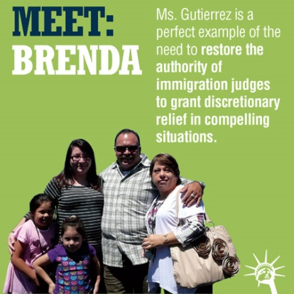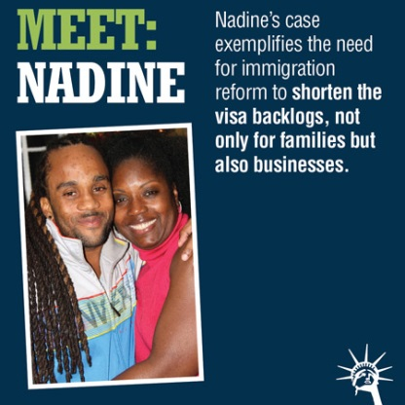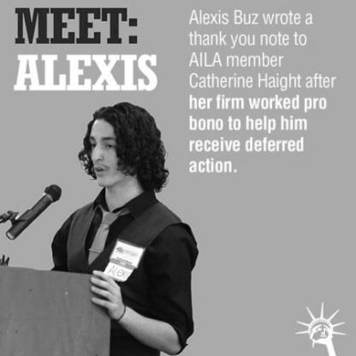

* **Family** immigration system issues (especially regarding siblings, adult married sons and daughters and people in visa backlogs)
* **Business** immigration system issues
* People facing the unlawful presence **bars**, *especially* the permanent bar.
* People who have been denied visas or relief from removal based on very minor or very old **crimes** (including shoplifting) or who have been denied visas based on alleged **gang affiliations** due to tattoos or inclusion in a gang database.
* **Mandatory detention** of those who have no criminal conviction whatsoever or whose conviction is for something very minor and nonviolent.
* Prolonged **detention** without bond hearing
* Problems with **state and local police enforcement** of immigration laws, including detainers, as well as examples of detainers being placed on juveniles.
* Misdemeanor crimes charged as **aggravated felonies**
* **Due Process** issues (use of expedited and administrative removal, judicial review, waivers)

**Your Contact Information:**

Name: _______________________________ Chapter: ________________________

Email: _______________________________ Phone: __________________________

Questions or to return this form, please contact Brittany Young at [BYoung@aila.org](mailto:BYoung@aila.org), (202)507-7669 (tel), or (202)783-7853 (fax).

This form is also available online at [www.aila.org/examples](http://www.aila.org/examples).

**Sample Email to Coalition Partners**

Dear Coalition Partner,

Over the next five weeks Members of Congress will be home, in-district, for the August Recess—this is an opportune time to influence their position on common sense immigration reform. Our local AILA Chapter is working with our national office to follow the debate and to influence these Members’ position on the importance of a vote on reform with a road to legalization and citizenship.

Working with a number of other national partners we are tracking local public events the Members of Congress will be hosting, as well as planning Letter to the Editor campaigns and an in-district lobby visit. We’d love to provide resources if helpful or collaborate on actions you’re already planning. Here are some of the things we have planned:

* [**Using the attached graphic**](http://www.aila.org/content/default.aspx?bc=6755|37861|25667|44179) with our social networks throughout the Recess to encourage calls into the Members office.
* **Attending Town hall** events and asking pro-immigration reform questions.
* Using the public [AILA Take Action tool to submit **Letters to the Editor**](http://www.capwiz.com/aila2/issues/alert/?alertid=62779941&type=ME)**.**
* [**Submitting case example**](http://www.aila.org/examples)**s** to AILA National.

It would be great to talk with you more about how we can work together over the next month—or if there are any specific resources AILA could provide.

Sincerely,